Hip & Non-Hip Roof Calculations
Hip Roof Calculation
A hip roof is calculated by the measuring the length of the non-hip roof roofs (document on the form).
The total perimeter is measured (document on the form). The total non-hip roof perimeters are then divided by the total roof perimeter. If the answer is less than 10%, then the roof is considered to be a HIP roof, and “A. Hip Roof” should be indicated on the form.
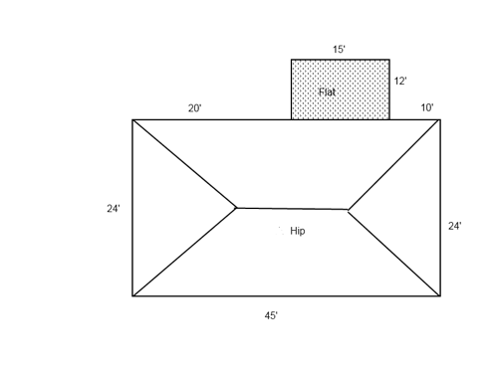
Calculations:
Flat (Non hip): 12+15+12= 39’
Total Perimeter: 45’+24’+10’+12’+15’+12’+20’+24’= 162’
Non-hip divided by total 39’ / 162’ = 24.07% or NON-HIP.
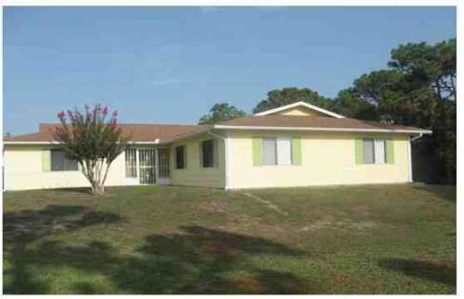
When measuring other roof features, include non-hip features that are not part of the perimeter, like the above picture of a Dutch hip roof and the sketch below.
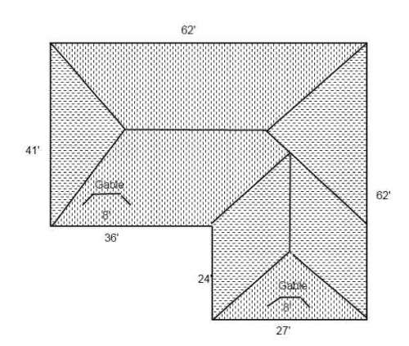
When measuring the perimeter, measure around the roof as a two dimensional object, such as from an aerial view. The non-hip features are measured as 8 feet plus 8 feet (8’ + 8’ = 16’), which equals 16 feet.
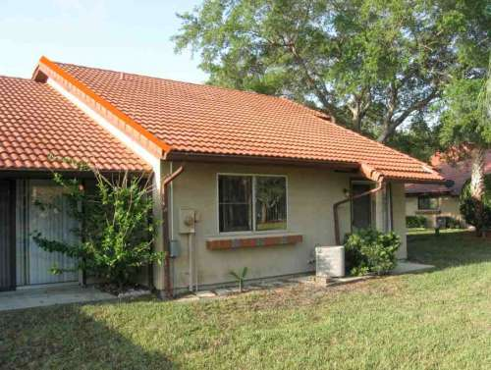
Gable included in the non-hip calculations.
Be sure to include all non-hip roof shapes when measuring the non-hip features.
Do not consider roofs or porches or carports that are attached only to the fascia or wall of the host structure over unenclosed space in the determination of the roof perimeter or roof area for roof geometry classification.

